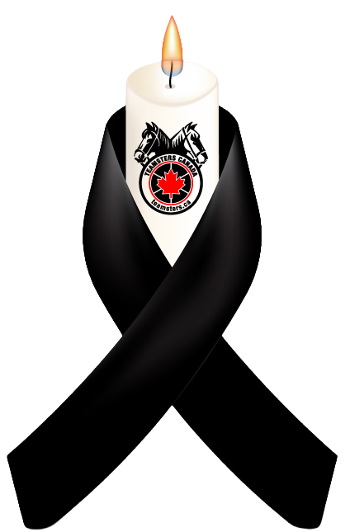

Teamsters Union Local 855 pauses today to join in remembrance to those workers who have died, were injured or became ill from their job.

We vow to continue our work to campaign for stronger laws to prevent workers from negligence and malpractice in the workplace.

We encourage all our members to take a moment to reflect, show solidarity and reaffirm their commitment to making safety a priority in their workplace

National Day of Mourning

